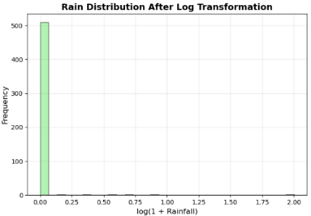
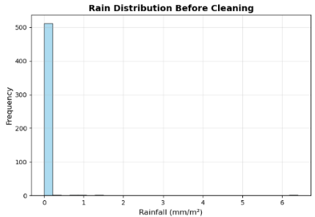
CSCU9M5 Assignment 1. Student Number 202316801527
4. Data Preparation
Variable Selected: rain (rainfall in mm/m²)
Issue: Rainfall data contains 98.5% zero values, causing extreme skewness (19.8).
Solution: Applied log(1+x) transformation to reduce skewness while preserving zeros.
Result: Skewness reduced by 29% (19.8 → 14.1). Most values (98.5%) remain zero after
transformation.
6. Final Model and Results
Selected Model: Random Forest (highest validation F1-score: 0.871)
Training Process: Best configuration retrained on combined training+ validation data (85% of total)
Test Set Performance (n=78):
Accuracy: 0.897
Precision: 0.929
Recall: 0.886
F1-Score: 0.907

Matrix Interpretation and Model Utility
Error Analysis: Correct Predictions: 70/78 samples (89.7%)
False Positives (3): Non-severe fires flagged as severe (low impact)
False Negatives (5): Severe fires missed (critical safety concern)
Model Practicality: High Precision (0.929): Severe fire warnings are 92.9% reliable
Good Recall (0.886): Detects 88.6% of actual severe fires
Safety-Oriented: Fewer missed warnings (5) than false alarms (3)
Suitable for deployment: Balanced performance supports operational decision-making
Confusion Matrix
 | Predicted F | Predicted T
Actual F | 31 | 3
Actual T | 5 | 39

(Hyperparameter tuning was implemented using Scikit-learn's model selection tools [2].)
Final Model Selection and Performance
Selected Model: Random Forest (highest validation F1-score: 0.871).
5. Model Training and Hyper Parameters
Hyperparameter selection method: Used Grid Search for Random Forest and SVM (testing all combinations) and Random Search for Neural Network (20 iterations), both with 5-fold cross-validation and F1-score optimization to address class imbalance.
Model | Hyperparameters | Validation F1-Score | Selection Method
Random Forest | n_estimators=100, max_depth=10, min_samples_split=2 | 0.871 | Grid Search (36 combinations)
Support Vector Machine | C=10, kernel='rbf', gamma='scale' | 0.727 | Grid Search (18 combinations)
Neural Network | hidden_layer_sizes=(64,), activation='relu' , alpha=0.01, learning_rate_init=0.01 | 0.795 | Random Search (20 iterations)

7. Insight about data or models gained
Key Drivers:
DMC (25.6%) and DC (25.5%) are the most important features - fuel moisture and drought conditions drive predictions.
Temperature (10.0%) and month (8.0%) provide additional seasonal context.
Rainfall (0.0%) has no predictive value in this dataset.
Bias Analysis:
No spatial bias: X (2.6%) and Y (3.2%) coordinates show minimal influence.
Balanced performance: Similar precision/recall for both classes (T:0.93/0.89 F：0.86/0.91）).
Explainability:
Random Forest provides clear feature importance, explaining why predictions are made.
Predictions are interpretable: High DMC/DC + high temperature = high probability of severe fire. Supports decision-making: Fire managers can trust and act on model predictions.
8. References
[1] P. Cortez and A. Morais, “A Data Mining Approach to Predict Forest Fires using Meteorological Data,” Jan. 2007.
[2] Scikit-Learn, “User guide: contents — scikit-learn 0.22.1 documentation,” Scikit-learn.org, 2019. https://scikit-learn.org/stable/user_guide.html
3 Variables/ Data Understanding
Variable | Used？ | Type | Treatment | Reason
X | Yes | Numeric Discrete | As-is (1-9) | Spatial coordinate for location patterns
Y | Yes | Numeric Discrete | As-is (2-9) | Spatial coordinate with X
Month | Yes | Categorical Ordinal | Encoded 1-12 | Seasonal fire risk patterns
Day | Yes | Categorical Ordinal | Encoded 1-7 | Weekly human activity patterns
FFMC | Yes | Numeric Continuous | MinMax scaled | Fine Fuel Moisture Code (FWI system)
DMC | Yes | Numeric Continuous | MinMax scaled | Duff Moisture Code (FWI system)
DC | Yes | Numeric Continuous | MinMax scaled | Drought Code - most important predictor
ISI | Yes | Numeric Continuous | MinMax scaled | Initial Spread Index (FWI system)
Temp | Yes | Numeric Continuous | Standard scaled | Temperature affects fire behavior
RH | Yes | Numeric Continuous | Standard scaled | Relative humidity affects fuel moisture
Wind | Yes | Numeric Continuous | Standard scaled | Wind speed accelerates fire spread
Rain | Yes | Numeric Continuous | Log(1+x) transform | Highly skewed (85% zeros), reduces outlier impact
Area | Target | Binary Categorical | Encoded 0/1 | T if burned area > 4%, F otherwise
Model Inputs and Output:
Input Variables (12): All features except 'area'，Output Variable: 'area' (binary classification: T/F)
Brief Explanation: All variables are used as each contributes to fire prediction. Fire weather indices (FFMC, DMC, DC, ISI) are scientifically validated predictors. Temporal variables use ordinal encoding to preserve order (January<February). Rainfall is log-transformed due to extreme skew. Meteorological variables are scaled appropriately for different algorithms.
2. Project Methodology
Objective: To build predictive models that classify whether a forest fire will burn more than 4% of the area using historical fire data from Montesinho Park. This project follows the CRISP-DM methodology [1]
Project Steps:
1.Data Loading & Exploration: Load dataset, check for missing values, and understand feature distributions
2.Data Cleaning & Preprocessing: Handle outliers, encode categorical variables, normalize/scale features
3.Train/Validate/Test Split: Use stratified 70%/15%/15% split to maintain class distribution
4.Model Selection: Choose Random Forest, SVM, and Neural Network as base algorithms
5.Hyperparameter Tuning: Use grid search with 5-fold cross-validation on validation set
6.Final Model Training: Train best model on combined training +validation data
7.Evaluation: Test on unseen test data using multiple metrics
8.Insights Extraction: Analyze feature importance and model behavior
Dataset Split: 361 training (70%), 78 validation (15%), 78 test (15%) - stratified to maintain class distribution.

